SOFTWARE APPLICATION TEST DOCUMENT
reliserv

Prepared By:
QA Team / Nyo Me Han
Organization:
ServiceBridge Team
Repository:
https://github.com/ServiceBridgeteam/reliserv
Date:
02-28-2026
Version:
1.0

CONFIDENTIAL — FOR INTERNAL USE ONLY

1. Document Revision History
Version | Date | Description | Author
1.0 | 02-28-2026 | Initial draft | Nyo Me Han

2. Introduction

2.1 Purpose
This document describes the test plan, test cases, and test results for the reliserv application maintained by ServiceBridge Team. It is intended to verify that all functional and non-functional requirements are correctly implemented and that the system behaves reliably under expected and edge-case conditions.

2.2 Scope
This test document covers the following areas of the reliserv application:
- Core service reliability and uptime functionality
- API endpoint behavior and response validation
- Service registration, discovery, and health-check mechanisms
- Authentication and authorization workflows
- Error handling and fault tolerance
- Performance under normal and peak load conditions
- Integration with dependent external services

2.3 Intended Audience
This document is intended for QA engineers, developers, project managers, and stakeholders involved in the reliserv project.

2.4 References
Document / Resource | Location / URL
GitHub Repository | https://github.com/ServiceBridgeteam/reliserv
API Documentation | [Link to API docs]
Project Vision | https://tamucc-my.sharepoint.com/:w:/r/personal/nlnu9_islander_tamucc_edu/_layouts/15/Doc.aspx?sourcedoc=%7B9853FB5E-B87C-4649-BECD-E7AC37DE4BEB%7D&file=1_Project%20Vision%20Document%20(PVD)%20Template%20202410%20(1).docx&action=default&mobileredirect=true
Project Plan | https://tamucc-my.sharepoint.com/:w:/r/personal/nlnu9_islander_tamucc_edu/_layouts/15/Doc.aspx?sourcedoc=%7B91BF65EB-D0A4-4767-AF3D-42FB9CB30F2F%7D&file=2_Project%20Plan%20(PP)%20Template%20202410.docx&action=default&mobileredirect=true

3. Test Objectives
The primary objectives of this test effort are:
- Verify that all specified functional requirements are correctly implemented.
- Validate that the application handles error states and edge cases gracefully.
- Confirm that performance benchmarks are met under load.
- Ensure security controls are enforced and cannot be bypassed.
- Confirm compatibility with supported environments and configurations.
- Identify and document defects for remediation before release.

4. Test Environment

4.1 Environment Summary
Parameter | Value
Environment Type | Development / Staging / Pre-Production
Operating System | Windows Server 2020 and above
Runtime / Language Version | Node.js
Database | PostgreSQL 15
Containerization | Docker / Kubernetes
CI/CD Pipeline | GitHub
Base URL | https://project-base-url/api

4.2 Test Tools
Tool | Purpose | Version
Postman / REST Client | API endpoint testing | 1.19.1
GitHub Actions | CI pipeline and automated test runs | N/A

4.3 Test Data
All test data used in this document is synthetic and does not contain real production data. Test data sets should be prepared in the test fixtures folder of the repository before execution.

5. Test Cases

5.1 API Validation

5.1.1 Authentication - Signup

Request
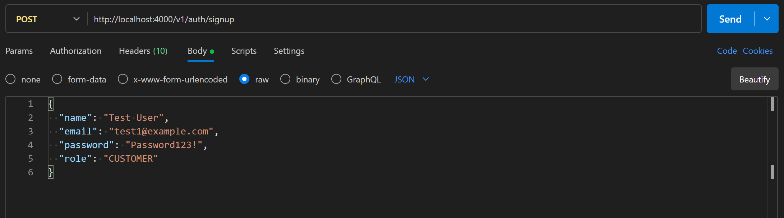

Response
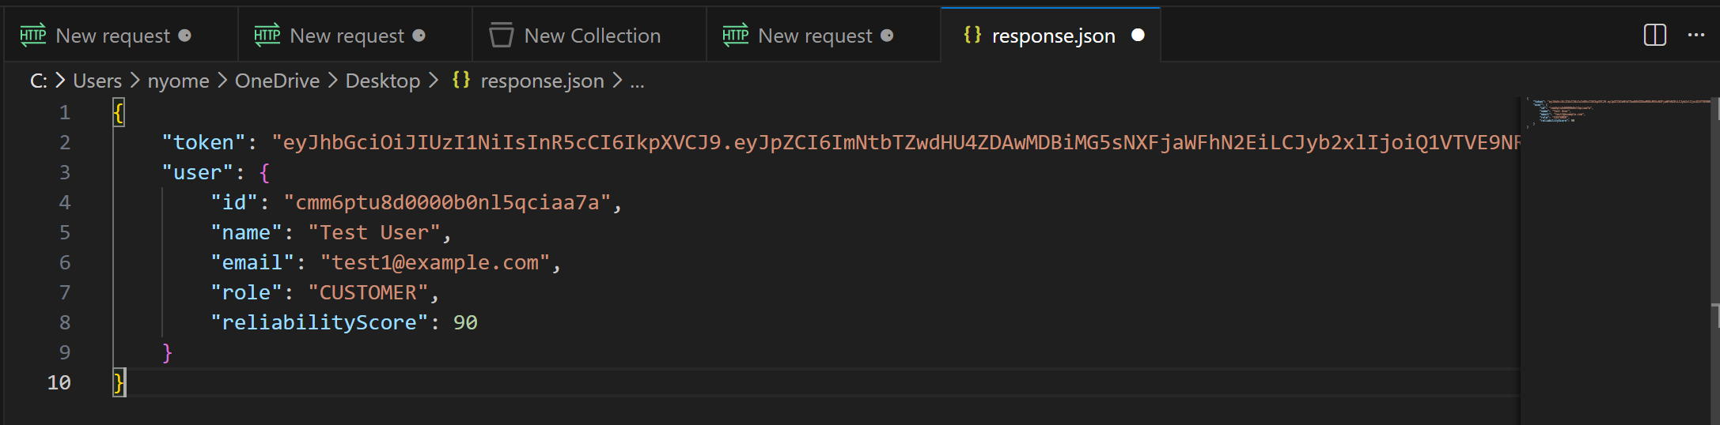

5.2 Configuration & Environment

5.2.1 JWT Middleware (Request - Response)

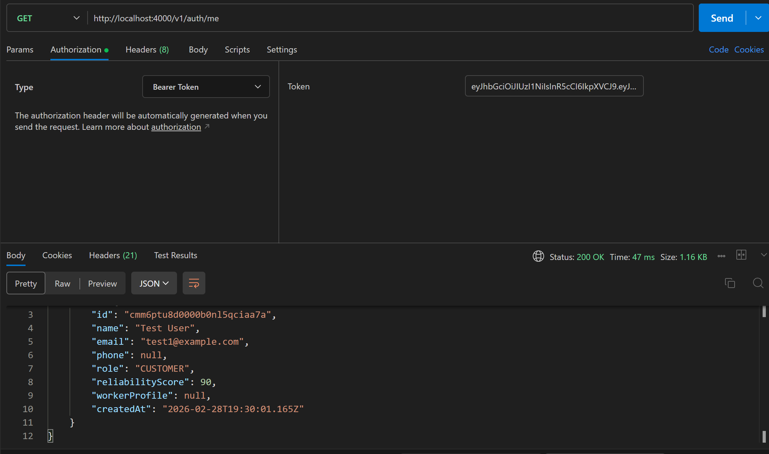

5.2.2 DB Proof — Prisma Studio (visual verification)

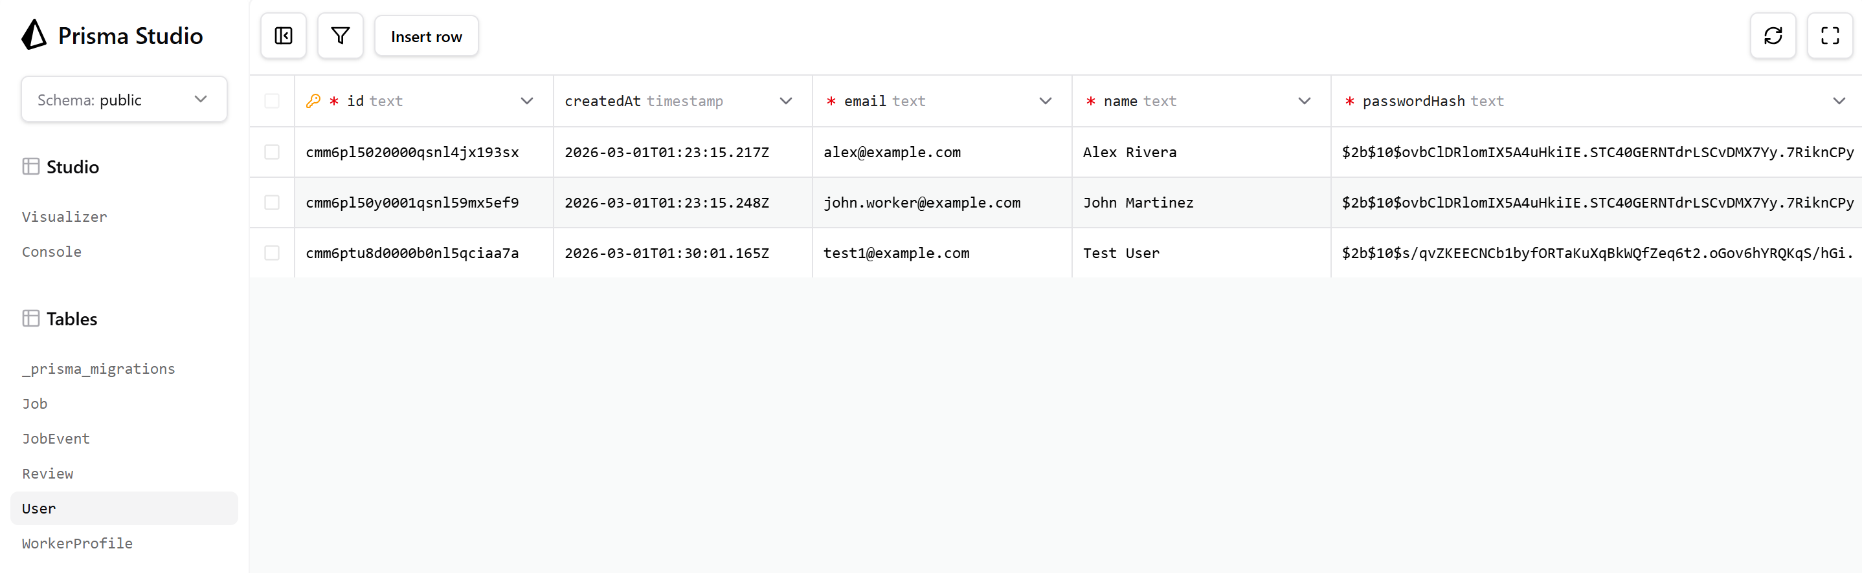

5.3 Core Service Functionality

5.3.1 Create Job

Request

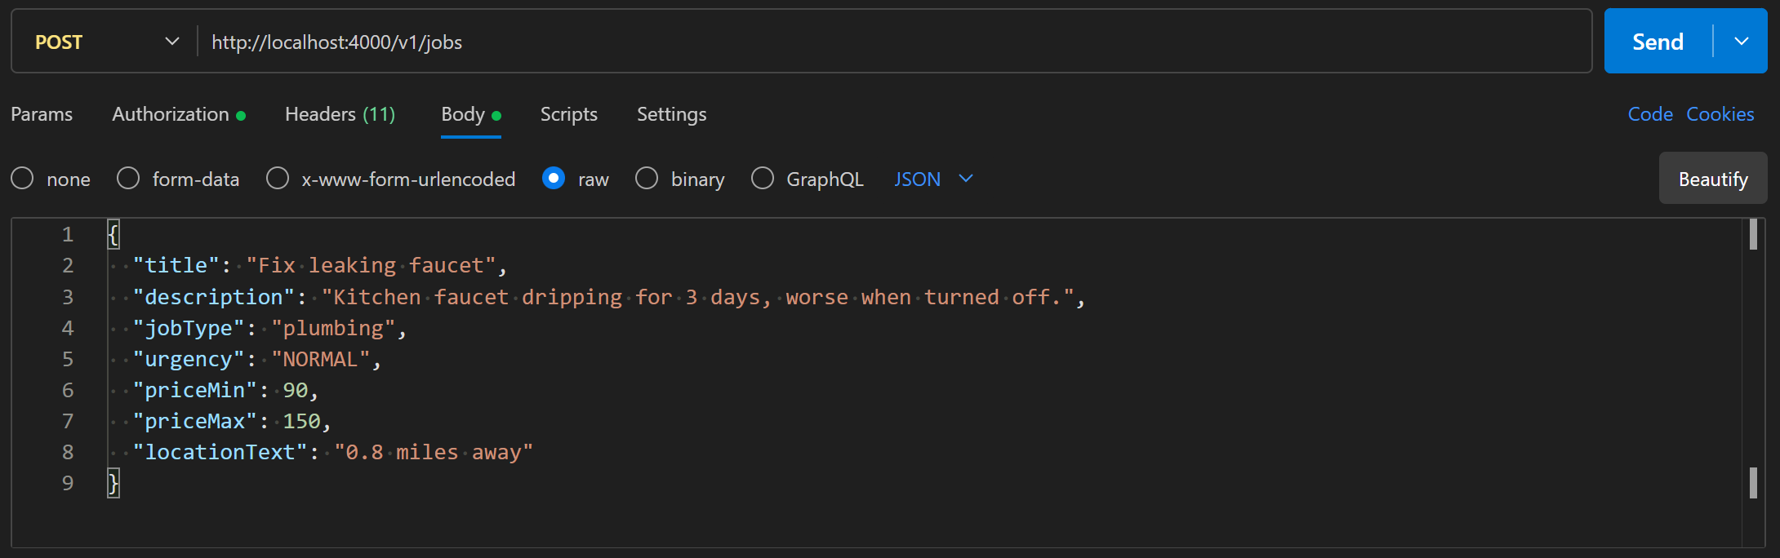

Response

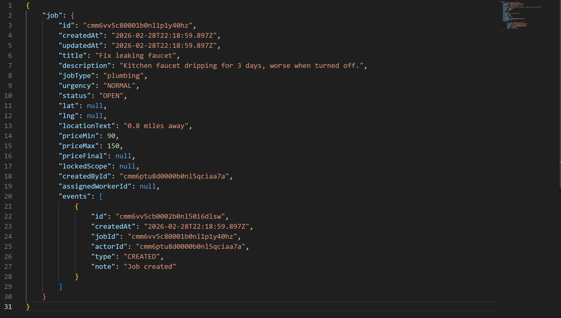

5.3.2 List Jobs (Request – Response)

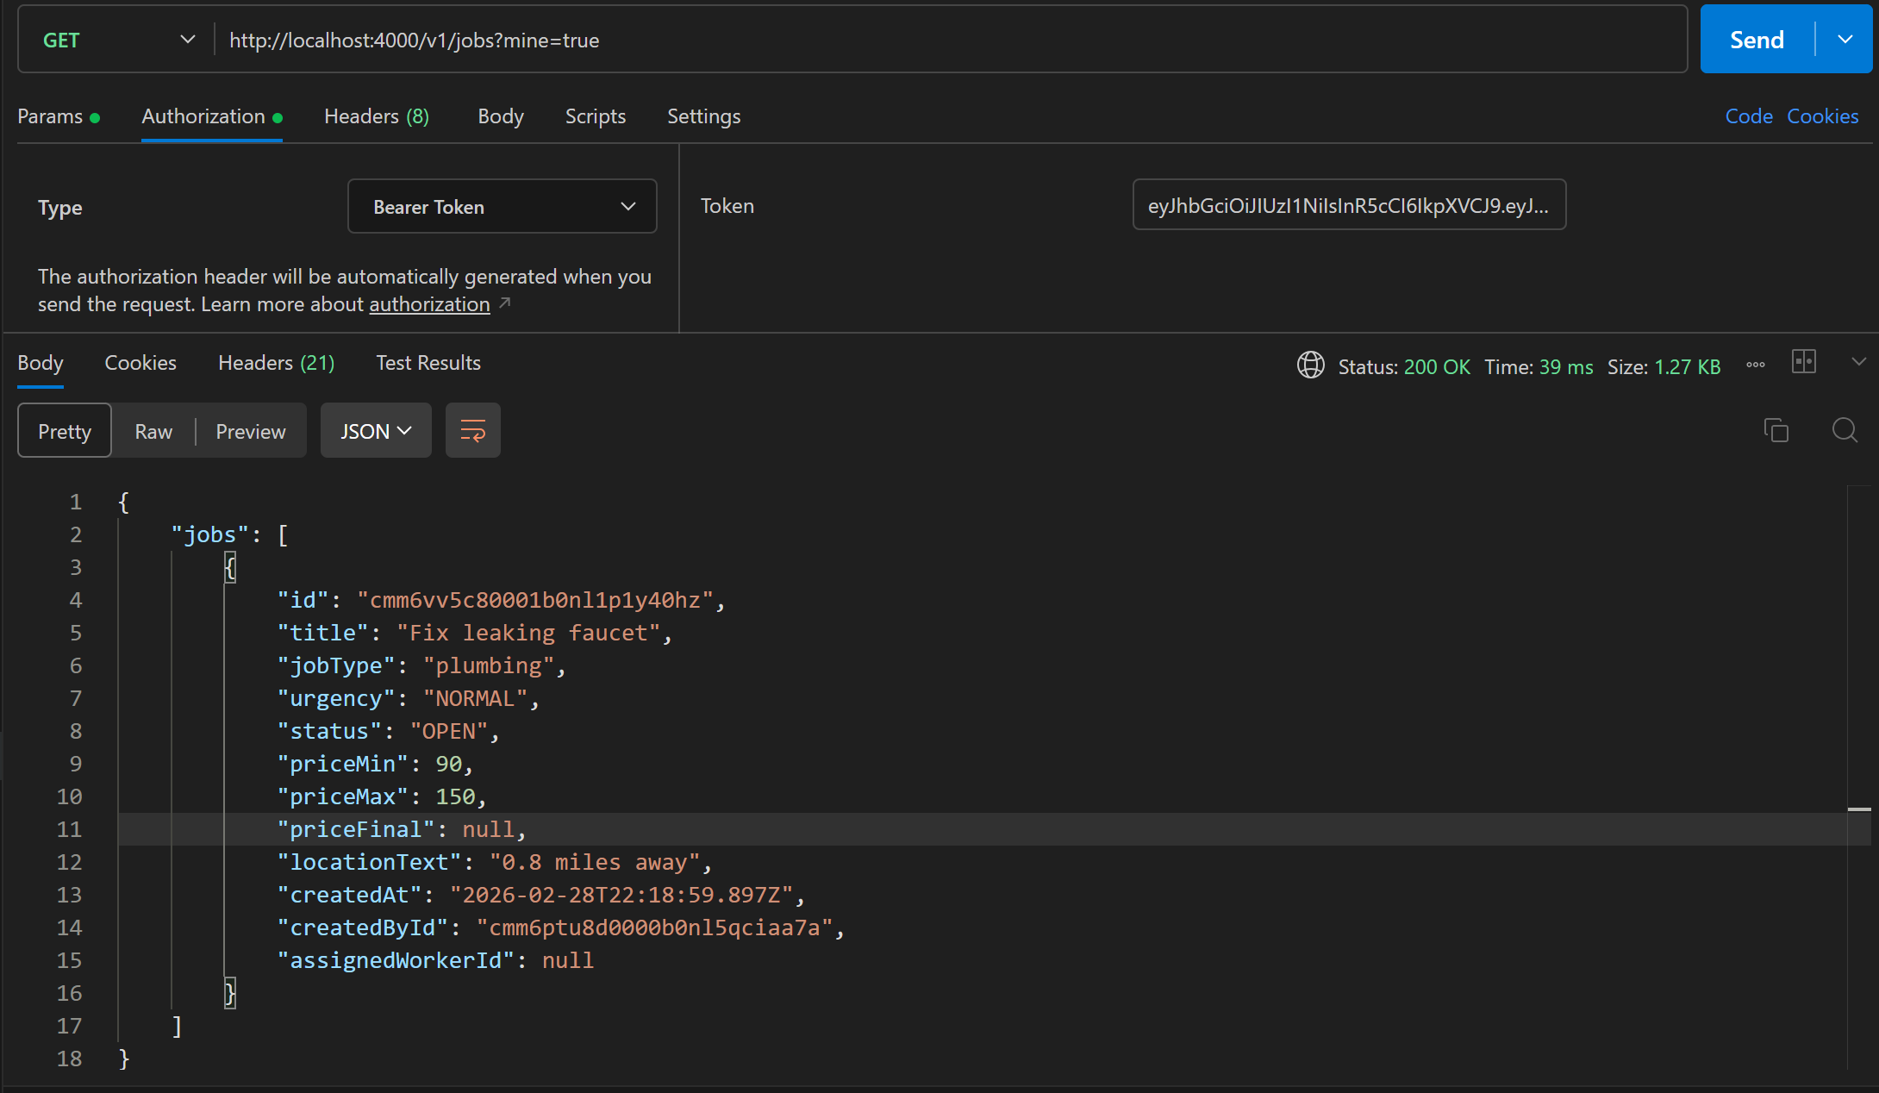

5.3.3 Get Job by ID

Request
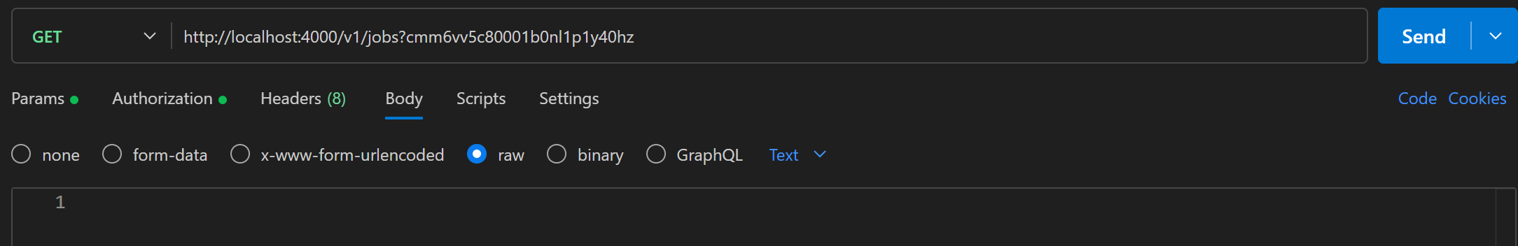

Response

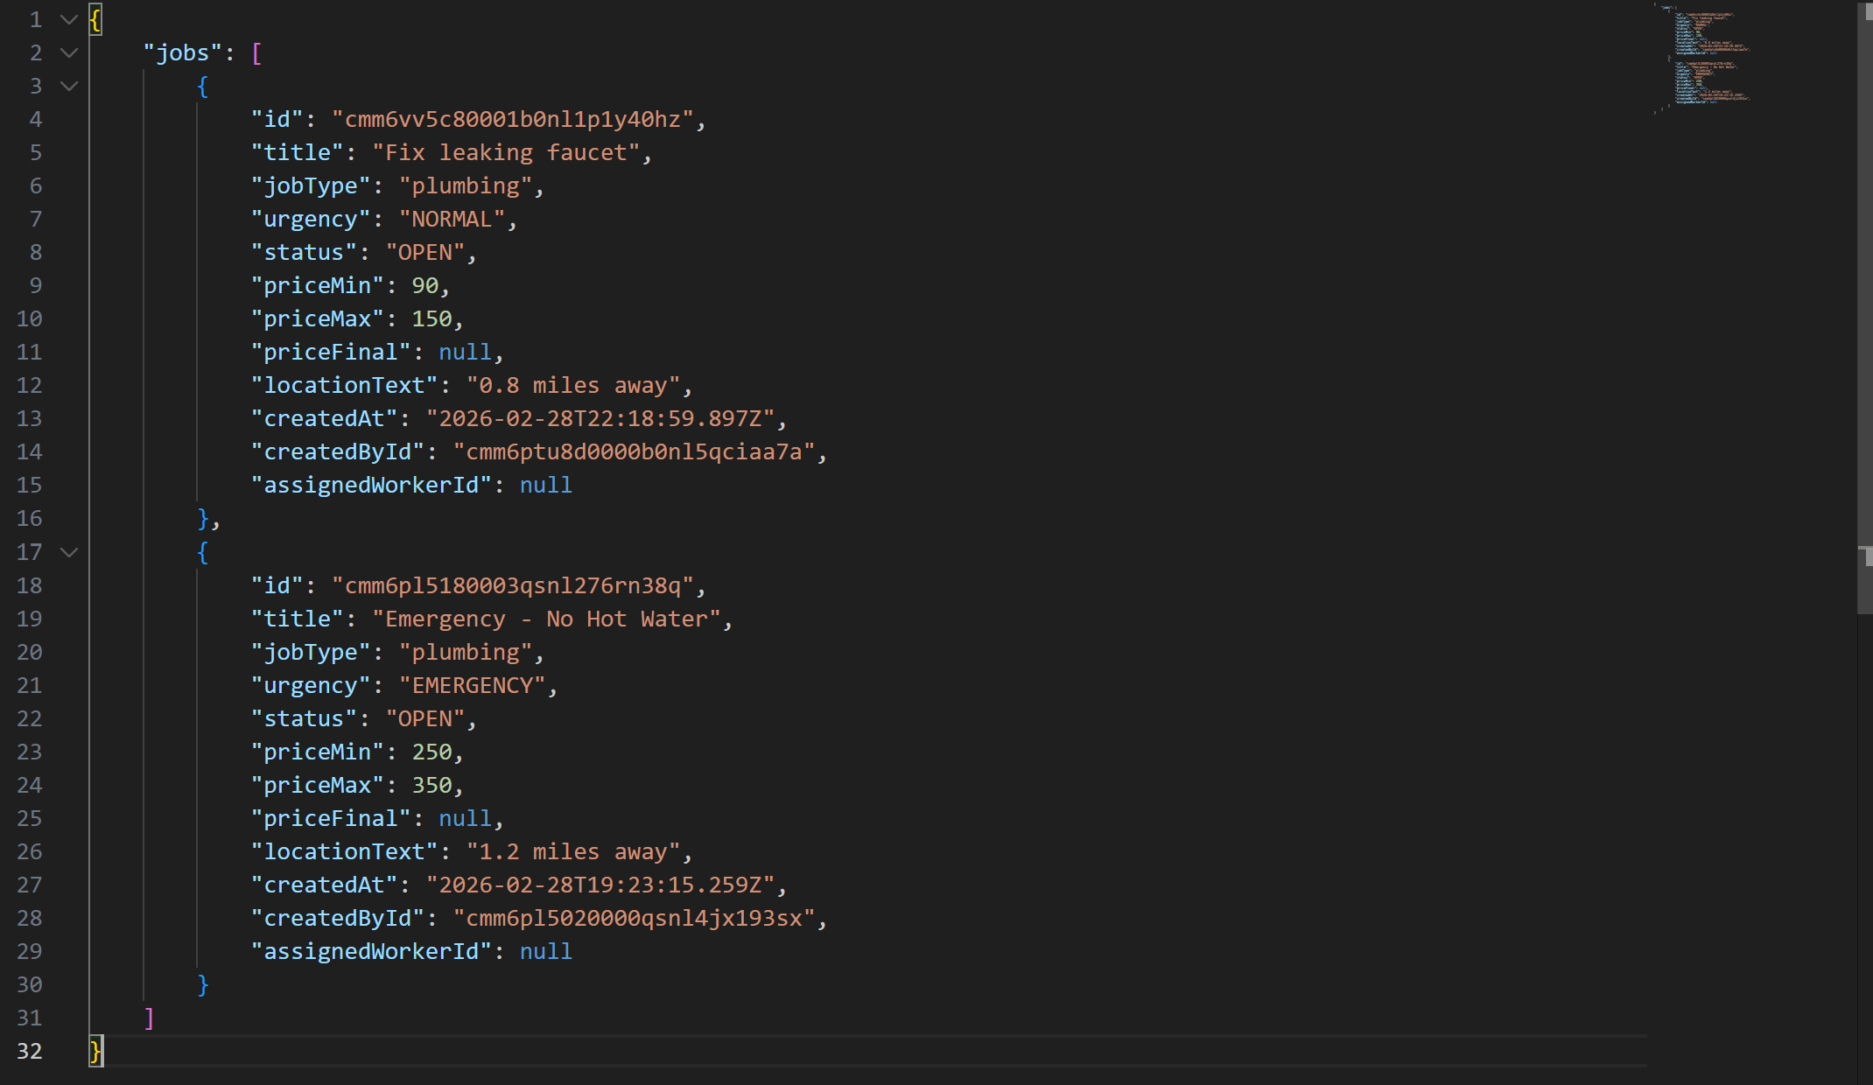

5.5 Security Proof

5.5.1 Validation Without Token
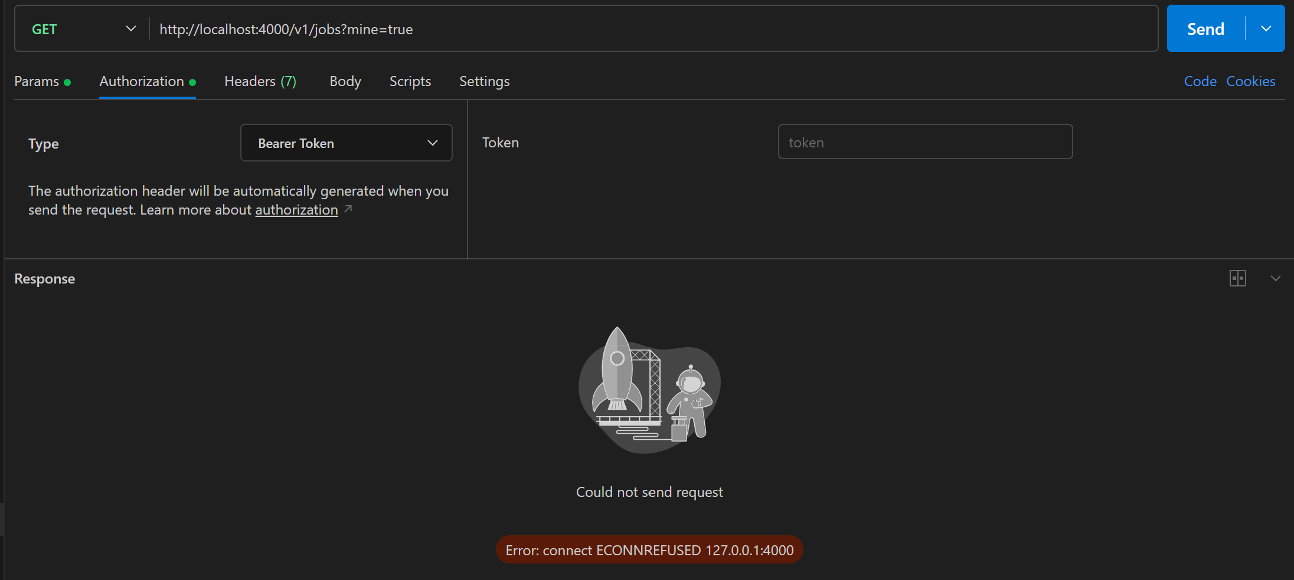

6. Defect Reporting

6.1 Defect Log
Instructions: Record all defects discovered during testing below. Link to GitHub Issues where applicable.

Defect ID | Title | TC ID(s) | Severity | Steps to Reproduce | Expected | Actual | Status | GitHub Issue
DEF-001 |  |  |  |  |  |  | N.A
DEF-002 |  |  |  |  |  |  | N.A
DEF-003 |  |  |  |  |  |  | N.A
DEF-004 |  |  |  |  |  |  | N.A

6.2 Severity Definitions
Severity | Definition
Critical | System crash, data loss, security breach, or complete feature failure blocking core workflows.
High | Major feature broken with no workaround; significantly impacts usability.
Medium | Feature partially broken; workaround exists but is burdensome.
Low | Minor cosmetic or non-blocking issue; minimal user impact.

7. Test Execution Summary

7.1 Execution Details
Parameter | Value
Test Cases | 5.1 – 5.5
Test Start Date | 02-28.2026
Test End Date | 02-28.2026
Executed By | Nyo Me Han
Environment | Development / Staging

7.2 Test Results Summary
Test Category | Total | Passed | Failed | Blocked | Not Run | Pass %
Authentication & Authorization | 1 | Yes |  |  |  | 100
Core Service Functionality | 3 | Yes |  |  |  | 100
API Validation & Error Handling | 0
Security Validation | 1 | Yes |  |  |  | 100
Performance Tests | 0
Configuration & Environment | 2 | Yes |  |  |  | 100
TOTAL | 7

7.3 Outstanding Risks
Risk | Likelihood | Impact | Mitigation
NA | NA
NA | NA

8. Sign-Off
The following stakeholders have reviewed and approved this test document:

Role | Name | Signature | Date
QA Lead | Nyo Me Han | NYO ME HAN | 02-28-2026
Development Lead
Product Owner / Manager
Release Manager

9. Abbreviations
Abbreviation | Definition
API | Application Programming Interface
CI/CD | Continuous Integration / Continuous Delivery
JWT | JSON Web Token
OOM | Out Of Memory
QA | Quality Assurance
RPS | Requests Per Second
SLA | Service Level Agreement
TC | Test Case
DEF | Defect
P95/P99 | 95th / 99th Percentile Latency

10. Notes & Additional Observations
Use this section to capture any additional observations, out-of-scope items, or information not covered elsewhere in this document.

[Add notes here]

